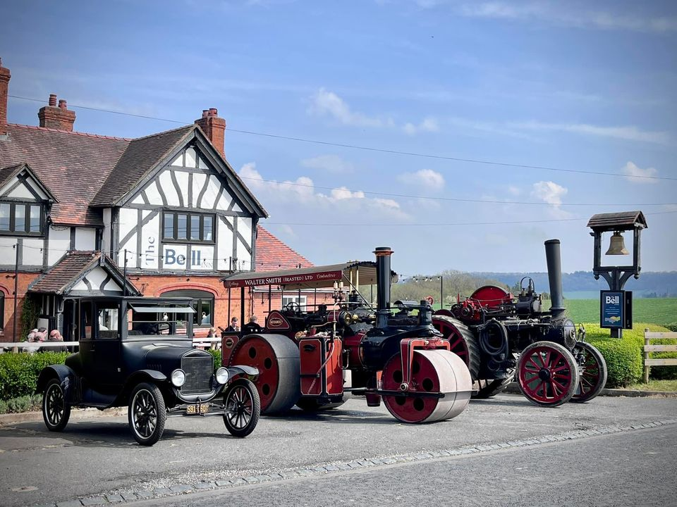

Pledge now to help Save The Bell at Pensax!!

The Save The Bell campaign has so far seen overwhelming support from the Community with 750+ people joining the Facebook site, 380 responses to a survey and many offers of personal and financial support.

A business valuation by industry specialist MJD Hughes Ltd was recently carried out, funded by community donations. This report concluded:

“From information available in the public domain, my investigations and meeting with the Save the Bell, and my experience of over 35 years in the licensed trade it is possible to see there is a sustainable business for the pub.”

We now plan to form a Community Benefit Society (registered with the Financial Conduct Authority) and raise sufficient funds from the Community to purchase The Bell freehold. Over 160 pubs are currently operating in this way in the UK and to date only one Community Pub has failed.

Our Community Share Offer will enable individuals (aged 16 or over) and/or corporate bodies to buy shares in the Society, making them a member of the society and giving them a vote at the Annual General Meeting.

No Commitment at this time

Whilst those pledging support will be under no obligation to purchase shares once the Community Share Offer is issued, we do ask that you think carefully about the amount you wish to pledge, as we will use this information to assess the viability of our plans; we do not want to risk misleading stakeholders about the level of support from within the community.

Q&A

A full list of questions and answers will be maintained at www.savethebellatpensax.co.uk
Ahead of the formation of the Community Benefit Society the following should be considered as indicative information only:

Q. How much do we need to raise?
A. Somewhere between £350k and £500k (to include purchase, renovation and working capital)
Q. How much can I pledge (per individual)?
A. Min £250, max. £25,000 and any amount in between in multiples of £250
Q. What do I get out of it?
A. Your pub back!! The Bell at Pensax has been a vibrant community hub for 150+ years. The possibility of losing this has been a huge shock for many. A Community purchase aims to secure its future.
Q. Will I receive any income?
A. At the discretion of the Board, a small interest rate might be paid.
Q. Can I get the money back?
A. It is expected that withdrawals will not be possible for a period of 2-3 years and after that at the discretion of the Management Committee

PLEDGE FORM
Investors must be over 16 years of age or corporate bodies.

We would prefer to capture your pledges online at www.savethebellatpensax.co.uk

Alternatively, please complete the below form and return it to:
Toby Wise, Westcroft, Bank Lane, Abberley, Worcester, WR6 6BQ

Name ..........................................................................................................................................
Full address .................................................................................................................................
...................................................................................................... Post code...............................
Telephone No. .............................................................................................................................
Email address: ..............................................................................................................................
Share cost £250. The minimum investment is one share. The maximum is 100 shares (£25,000).
Number of shares: ....................................... Value of shares: ...............................
I agree to my name, address, phone number, email address, number and value of shares being held in an electronic register. All information including proposed investment amounts are strictly confidential.
I understand that this information may be used for the purpose of maintaining a register of members as required by the rules of the Society and will not be passed to third parties.

Signed ............................................................................. Date ..................................................

